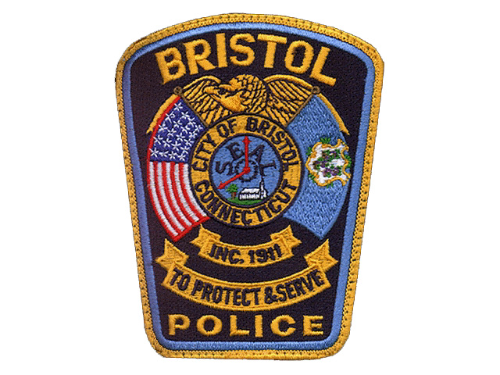
Bristol Connecticut Police Dept

131 North Main Street
Bristol CT 06010

(860) 584-3000
ALARM REGISTRATION FORM

Per Ordinance Section 2.5

Pursuant to City of Bristol ordinance section #2.5 “Alarm Systems”, all residential and business alarm systems must be registered with the Bristol Police Department.

Why do alarms systems have to be registered?
One primary reason for the ordinance is to reduce the number of false alarms generated. The Bristol Police respond to every alarm as if it may be an incident in progress. Police officers spend time checking the property and responding to false alarms ties up manpower. False alarms cost taxpayers and divert officers from legitimate emergencies. The ordinance encourages accountability and improvement in the reliability of alarm systems by charging alarm owners for false alarms after the 3rd occurrence each year.

** ALL INFORMATION WILL REMAIN STRICTLY CONFIDENTIAL **

Registrant Information
Name:
Street Address / Alarm Location:
Mailing Address: Email (Optional):
Home Phone: Business Phone: Cell Phone:
Property Owner (if different than Registrant): Phone #:

Emergency Contact Information (List contact names in the order you would like to have them called)
#1-Name/Relationship: Phone 1: Phone 2:
#2-Name/Relationship: Phone 1: Phone 2:
#3-Name/Relationship: Phone 1: Phone 2:

Alarm Information
Alarm Location Type (circle one) => RESIDENTIAL .. or .. COMMERCIAL
Type of Alarm (circle all applicable) => Burglar Panic Fire Other:______________________
Alarm Routing (circle one) => CENTRAL STATION .. or .. LOCAL ALARM
This Alarm is (circle one) => SILENT .. or .. AUDIBLE
Alarm Company Information: Name:
Date Installed:____________ Address:
Phone:

The registrant hereby agrees to comply with the provisions of City of Bristol CT Ordinance section #2.5 “Alarms Systems”. The registrant also understands that he/she shall be accountable for false alarms, excluding those caused by severe weather. Warnings and fines shall be issued pursuant to Ordinance section #2.5.

_________________________________________________ _________________________________
Signature of Registrant Date

Send or bring completed form to:

The Bristol Police Department Records Division (BPD Records Division open M~F, 9am ~ 4:30pm)

131 North Main Street, Bristol CT 06010

